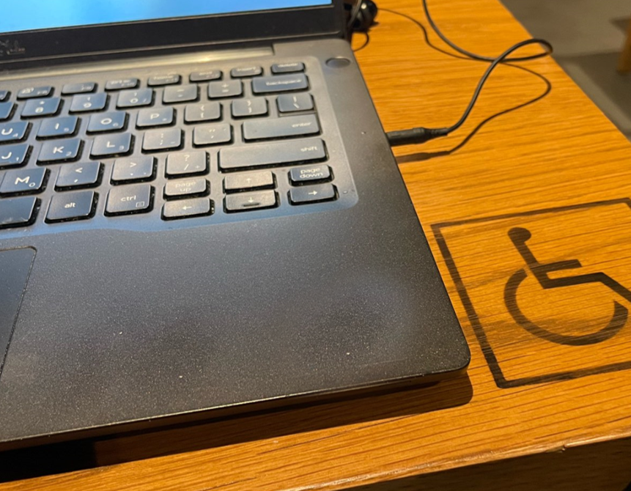

Quick Guide to Document Accessibility
T. Matthew Weissenberger, University of Iowa
Rev. Fall 2025
Summary 3
Selected practices for document accessibility 3
One Absolute Rule: Do not share image-only or “flat” files 4
Use headings and structure to organize your content 5
Tips for providing good structure 5
Examples 5
Provide appropriate alternative text (ALT text) 6
Tips for providing good ALT text 6
Examples 6
Provide descriptive link text 7
Tips for providing good hyperlinks 7
Examples 7
Make good use of color 8
Tips for effective color management 8
Use semantic lists correctly 8
Tips for providing accessible lists 8
Use well-structured tables to present data 9
Tips for providing accessible tables 9
Ensure the accessibility of online media 9
Tips for providing accessible online media 9
Ensure that content is presented in the right order 10
Tips for presenting content in logical reading order 10
Accessibility testing 11
Selected accessibility testing tools 11
Conclusion 12
Accessibility Statement 13

Summary
Documents that are shared digitally need to be accessible for everyone. Accessible documents enable all people, including people with disabilities, to take part effectively and independently in academic, professional, and community activities. Accessible documents combine best practices in document design with best practices in accessibility.
The techniques described in this document are intended for use alongside style guides for print, electronic, or web authoring, and the recommendations apply to a wide range of document formats and tools. Whether you create Word or Google docs, web pages, PDF documents, emails, or documents in other formats, you can adopt a few simple practices to make your documents more accessible for all users.

Selected practices for document accessibility
- Do not distribute flat-file or image-only documents
- Use headings, document title, and structural elements to organize your documents
- Provide alternative text (ALT text) for images that present content
- Provide descriptive text for any hyperlinks, buttons, or other interactive elements
- Use authoring tools to create tables, lists, and other semantic document elements
- Check your colors to ensure sufficient contrast
- Do not use color as the sole means of distinguishing an element
- Use styles, stylesheets, and themes to manage fonts, colors, and other visual formatting
- Make sure that your content is presented in the right order
Not all techniques will apply in all situations, and some situations may call for an approach not described here. Always check the accessibility of your digital documents and other products at regular stages throughout the design and development process.

One Absolute Rule: Do not share image-only or “flat” files

Image-only or “flat-file” formats present complications in usability, access, and management. These documents often look like regular text files, but they are “flattened” and no longer machine-readable. This makes them completely inaccessible to most assistive technology. It also strips away basic functionality like copy/paste and search, affecting all users. Image-only document should not be confused with images, which may be embedded in a variety of document formats.
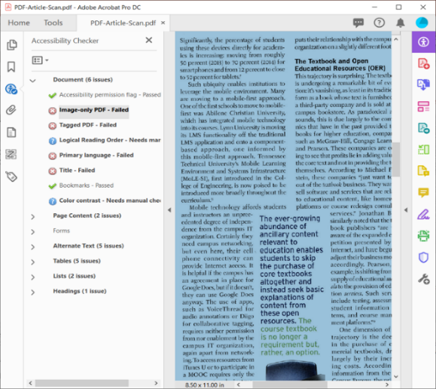
Scanned PDF documents often render as flat files

Use headings and structure to organize your content
Headings (e.g., H1, heading 1) let you organize your content into an outline of topics and regions. This nested document structure makes it easier to quickly scan and navigate your document. Some formats use headings to create bookmarks, tables of contents, and other navigational aids. Page title and language, appropriate sectioning, semantic elements, and metainformation are other elements that can improve the readability of your document.

Tips for providing good structure
- Use a first-level heading to provide a meaningful document title for each document
- Use level 2 headings to introduce new topics or sections in your document
- Separate your document into sections, regions, or landmarks where appropriate
- Do not skip heading levels
- Use headings to provide a table of contents, bookmarks, sitemap, or other navigational supports for your end user
- Do not use headings for blocks of body text or for stylistic purposes
- Do not use tabs to simulate columns, tables, lists, or other structures

Examples

Webpage headings applied in the Drupal web editor
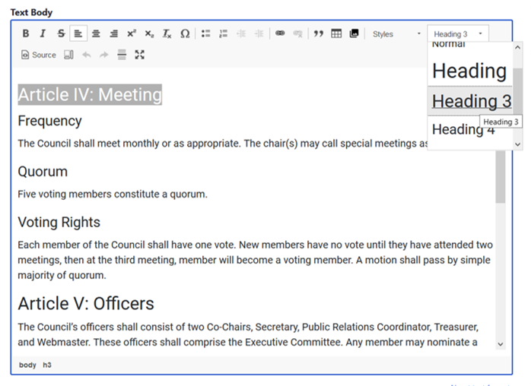

Webpage heading structure in Web Developer Toolbar
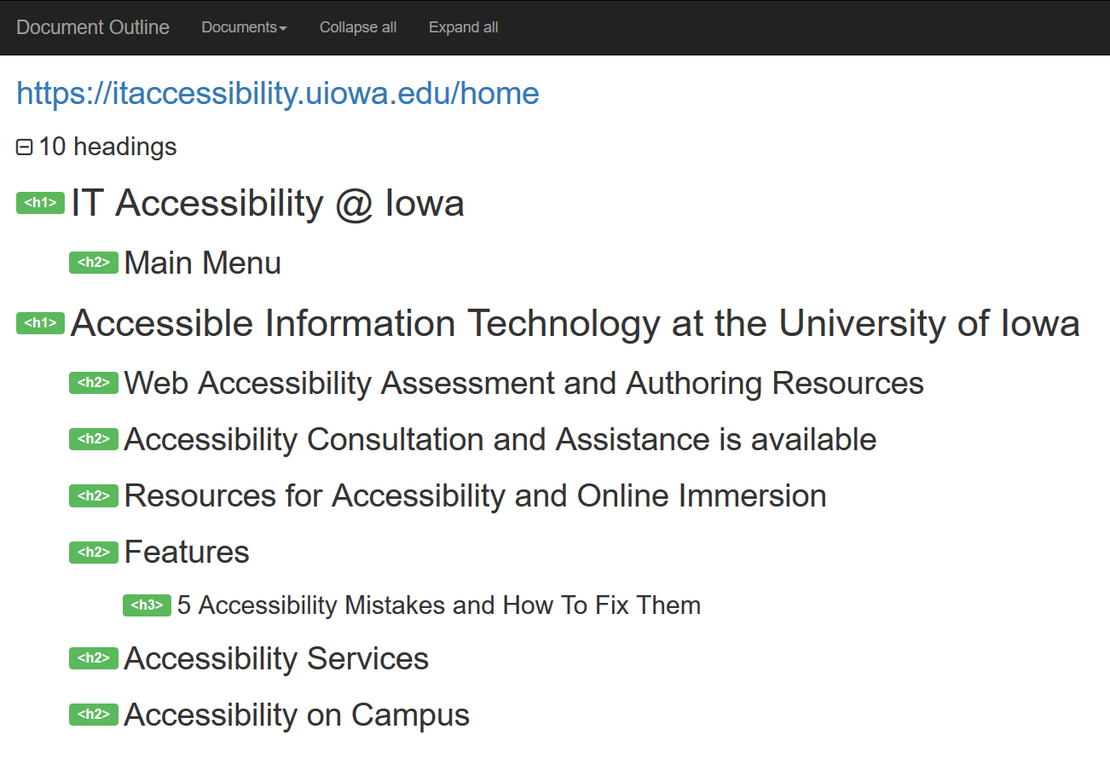

Document heading styles applied in Microsoft Word
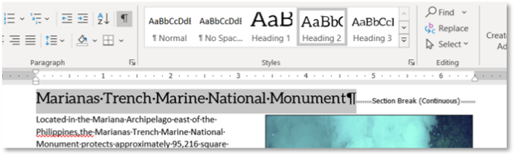

Microsoft Word heading structure, in Navigation Pane
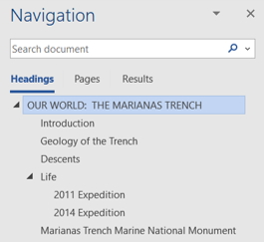

Ensure that content is presented in the right order

Some tools will present information in a different order depending on how the reader accesses a document. Always check your document to make sure the logical reading order is observed for visual readers, assisted readers, and screen readers.

Tips for presenting content in logical reading order
- Read the content with a screen reader
- Use a built-in tool to review the reading order of the content
- Copy the content and paste it into Notepad or a text editor to determine reading order
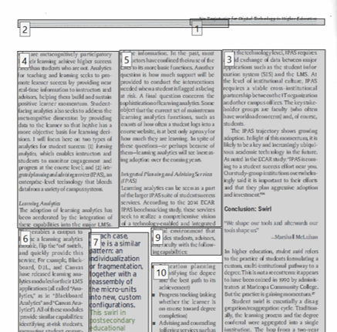
PDF viewed with the Reading Order tool in Adobe Acrobat

Provide appropriate alternative text (ALT text)
Most document and web editors let you add text descriptions (“ALT text”) of images in your documents. Make sure your ALT text adequately conveys the content and purpose of any images you include in your documents.

Tips for providing good ALT text
- For simple images, keep the description concise: not more than 140 characters
- For images that require longer descriptions (e.g., charts or graphs), provide ALT text and a link to a detailed description
- For images of text (e.g., logos, wordmarks), use the image text as the ALT text
- Avoid using terms like “Picture of…” or “Image of…”; assistive technologies will provide that information to the end user
- Be sure to provide ALT text with images that are used as buttons or links
- Decorative images, spacer images, images combined with text links, and images described by adjacent text may not need ALT text

Examples

“Students working in the ICATER computer lab”

“A cup of coffee, spilled onto a laptop keyboard”
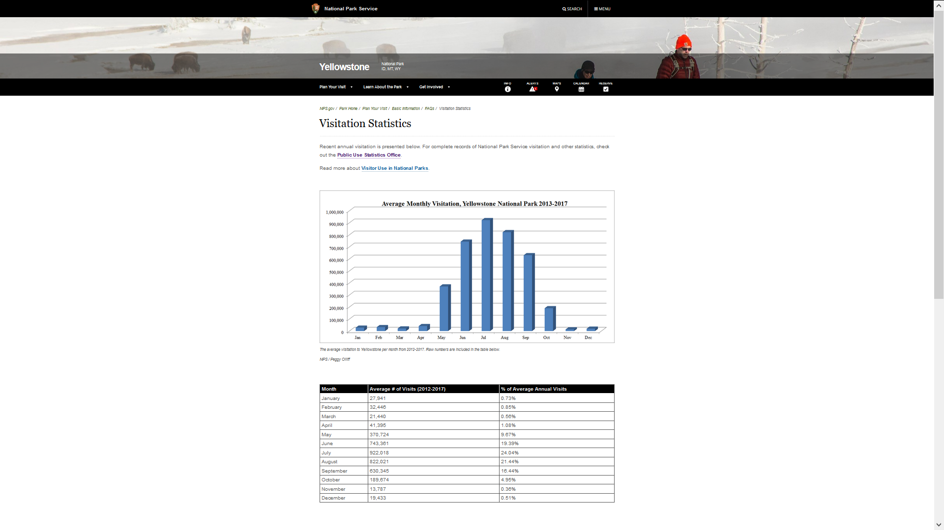“Chart of Yellowstone Park visitors; see Appendix B for complete data”

“Seal, State of Iowa
Board of Regents”

Provide descriptive link text
Hyperlinks are now a fundamental part of almost any document type. By providing links that are clearly labeled and easy to find and use, you make your document more navigable for everyone.
Hyperlink text should clearly indicate the purpose and destination of the link. Links presented by image should include good ALT text.

Tips for providing good hyperlinks
- Underline links so that they are easy to distinguish from the surrounding content
- Avoid generic link text such as "Learn More", "Click Here", or “Go”; instead, use descriptive text like “Spring Orientation Schedule” or a call to action like “View Nondiscrimination Statement”
- Do not use the URL as link text in digital or print documents; instead, place it AFTER the link text
- If you an image as a link, the ALT text becomes the link text
- If you combine image and text to make a link, place both in the same link container
- Links to the same resource should use the same or similar text
- Use links only for navigation; do not use links as buttons or buttons as links

Examples
Inactive links for demonstration purposes only
Uninformative or generic link text | Informative, contextual link text
Click Here | Register for the May 21 Workshop
Get in touch | Contact the ITS Help Desk
http://www.amazon.com/exec/obidos/ASIN/159058/qid=1116951/sr=2-1/ref=pd_2_1/103-5755258-8233 | Zhi, Chapter 8 (PDF, 388KB)  Buy the book at A11yReads.com
View website | Visit the IT Accessibility website [https://itaccessibility.uiowa.edu]
Submit | Submit application and return to main site

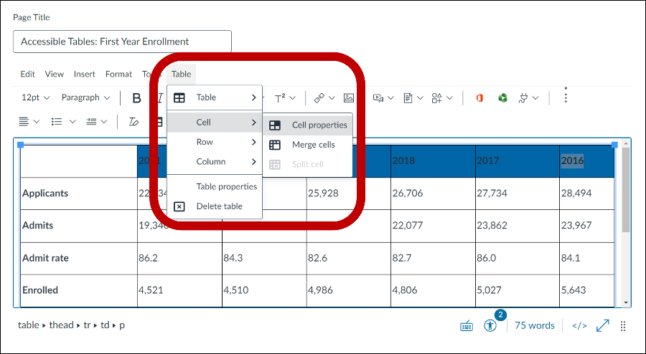
Use well-structured tables to present data
Tables should be used to present data in rows and columns. Simple tables are reasonably accessible when they include standard semantic markup for header and data cells, and some basic identifying information.

Tips for providing accessible tables
- Keep tables simple; avoid merging or splitting cells
- Create a separate table for each set of data; do not nest or combine tables
- Use <th> for header cells, and apply the appropriate SCOPE attribute
- Provide a meaningful name for the table (CAPTION, ARIA-LABEL, ARIA-LABELLEDBY)
- Include ID and HEADERS attributes in data cells for complex tables

Use semantic lists correctly
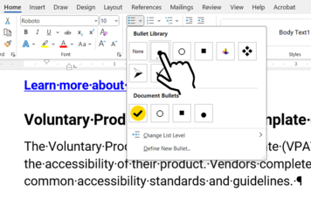
Most authoring tools include ways to make bulleted, numbered, or multi-level lists. Lists can provide assistive technology with information about the number and position of items in a sequence or relationship. Depending on your document format and authoring tool, you may be able to create nested or outline lists

Tips for providing accessible lists
- Use the list tools in your authoring application to create lists
- Use bulleted, numbered, and outline lists for their respective purposes
- Do not use lists for stylistic purposes like indentation

Make good use of color

All text, logos, and images need a level of contrast that makes them readable by low-vision or color-blind users. In general, light text should go on a dark background, and dark text on a lighter background. Also, color should not be the only means of distinguishing content; make sure that content is differentiated by pattern, style, text, shape, or other visual traits.

Tips for effective color management
- Adhere to foreground and background colors identified in the University Style Guide
- Avoid using color as the only way to identify an object
- Check your color contrast using an tool like the WebAIM Color Contrast Checker (https://webaim.org/resources/contrastchecker/)
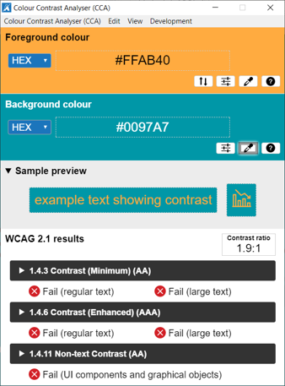
The Color Contrast Analyzer indicates failures of WCAG contrast guidelines

Ensure the accessibility of online media

Video captions are an essential aspect of digital accessibility. For users who are deaf or hard of hearing, captions may be the only way to perceive the message in your media.
Captions benefit all users. Non-native English speakers can use them to reinforce a lecture; users in loud or distracting environments can read them without headphones; search engines can index the content of caption files; and you can retain control over your message.

Tips for providing accessible online media
- Provide captions for all online video
- Provide a text transcript for all online audio
- Use audio descriptions to describe onscreen activity
- Make sure media players are keyboard-and screen reader accessible
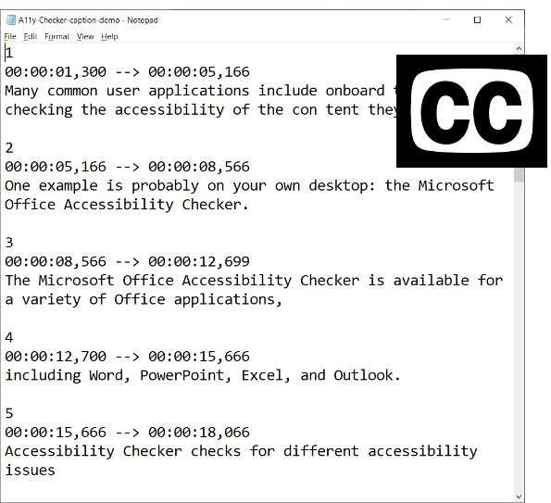

Accessibility testing
Accessibility testing is an important part of your IT Accessibility efforts. Testing can measure outcomes and effectiveness in multiple areas, including:
- Conformance with applicable accessibility standards (e.g., WCAG, ATAG, WCAG2ICT)
- Completion of accessibility testing protocols
- Compatibility with assistive technologies
In broad terms, there are two modes of accessibility testing: automated testing and manual testing. Accessibility checkers are automated tools that help you to identify accessibility issues. Accessibility checkers exist for most document formats. They may be fully integrated into an authoring tool like Microsoft Word, or they may be stand-alone tools like Siteimprove or Color Contrast Analyzer.
Automated checkers are useful, but they can only detect certain kinds of accessibility issues. A complete accessibility strategy needs to include other modes of testing. Manual testing by authors and other users, heuristic testing, and testing with assistive technology all help you better understand the accessibility of your documents.

Selected accessibility testing tools
Tool | Intended for Testing | Features
Microsoft Office Accessibility Checkers | Tools in the Microsoft Office suite. | Built into selected Microsoft Office products. Specific checks vary by product.
Adobe Acrobat Pro Accessibility Checker | PDF in Adobe Acrobat Pro. Acrobat Pro includes tools to remediate some accessibility issues. | Built into Adobe Acrobat Pro. Checks 32 accessibility issues and generates a report.
PDF Accessibility Checker 3 (PAC 3) | PDF documents. | Checks for all automated guidelines of PDF/UA. No tools for remediation.
Siteimprove | Websites, PDF, some quality assurance not directly related to accessibility | Scans websites and code; generates a report on selected accessibility issues.
WAVE, ANDI | Individual web pages | Scans individual web pages and generates a report on selected accessibility issues.
Color Contrast Analyzer | Color pairings in any digital format | Compares two colors; compares values reports WCAG conformance

Conclusion
Digital accessibility is a key aspect of an inclusive and equitable learning environment. Faculty and instructors have a unique opportunity to advance academic inclusion through intentional applications of accessibility.
Accessibility is a journey, not a destination. This document serves as an introduction to accessible digital documents. For additional information and support, contact your institution’s disability services office, accessibility team, or ADA coordinator.

Accessibility Statement
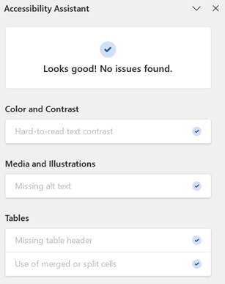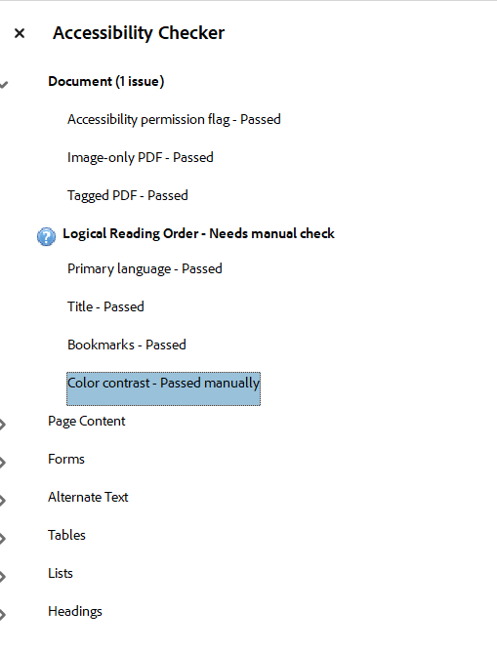
This document is regularly reviewed for accessibility. This version passes all issues tracked by the Microsoft Word Accessibility Checker. Logical Reading Order may be inconsistent in the PDF version of this document.
If you experience or identify an accessibility issue associated with this document, please contact T.M. Weissenberger.

